A deep learning system based on YOLO for finding insects in real time in agriculture

Anant Raj
Student SCSE, IILM University Greater Noida, India
anant.raj.cs28@iilm.edu

Swati Vashisht
Assistant Professor SCSE, IILM University Greater Noida, India
msswativashisht@gmail.com

Sandeep
Student SCSE, IILM University Greater Noida, India
sandeep.cs28@iilm.edu

Bhavya Yadav
Student SCSE, IILM university Greater Noida, India
bhavya.yadav.cs28@iilm.edu

Saurav Kumar
Student SCSE, IILM University Greater Noida, India
saurav.kumar.cs28@iilm.edu

Siddhant Singh Somvanshi
Student SCSE, IILM University Greater Noida, India
siddhant.somvanshi.cs28@iilm.edu

Managing pests on farms is an important part of Food security and modern ways to protect crops. This study introduces a YOLO-based deep learning framework for real-time agricultural pest detection utilizing the YOLOv8 architecture Roboflow exported an annotated pest dataset that had five pest categories: weevil, caterpillar, grasshopper, slug, and snail. The suggested system's mean Average Precision (mAP@0.5) for all pest classes is 0.952. The AP scores for each class range from 0.849 for caterpillars to 0.995 for snails and grasshoppers. To make sure that the framework works well in a variety of field situations, It uses data augmentation methods, decoupled anchor-free detection heads, and multi-scale feature pyramid networks. Tests on Google Colab's GPU infrastructure show that the system works much better than baseline models like YOLOv5 and Faster R-CNN, which can process more than 60 frames per second in real time with good accuracy and speed. Some uses are automated systems for monitoring crops, drones for field surveillance, and platforms for precision agriculture, and smart farms can get help and advice. Future research will focus on expanding the framework to include additional crop and pest species, along with more advanced YOLO variants and getting it to work on edge devices with limited resources.
Keywords: YOLOv8, Deep Learning, Object Detection, Precision Agriculture, and Real-Time Inference Neural networks for finding pests on crops

Introduction
Modern farming depends a lot on pest control because it helps crops grow, makes food safer, and lets pesticides be used more accurately. Farmers, agronomists, lawmakers, and operators of agritech platforms are just a few of the people who would benefit from quick and accurate information about pest infestations. Traditional pest monitoring methods have relied on labor intensive field scouting or sensor-based trapping devices, which are expensive, intrusive, and difficult to use in large agricultural areas. Recent developments in computer vision, deep learning, and artificial intelligence (AI) have enabled the rapid and highly accurate automatic identification of intricate pest interaction dynamics. [1][11].
Real-time identification of agricultural pests poses distinct and intricate technical challenges. It can be hard to find small bugs because they look alike across species, plant leaves often hide them, the soil texture changes, and the lighting isn't always the same. Moreover, models capable of encapsulating intricate spatial and contextual interactions across multiple dimensions are essential for the precise localization of particular pest species, including caterpillars, grasshoppers, slugs, snails, and weevils [4][15]. To deal with these problems, we need strong deep learning architectures that can find pests and sort them by species in real time.
The You Only Look Once (YOLO) family of single-stage detectors has become the most popular way to find objects in real time because they are very good at both accuracy and speed of inference [1][2][3]. This paper introduces a structured YOLOv8-based framework specifically designed for the detection of agricultural pests. Our contributions encompass: (i) a comprehensive end-to-end detection pipeline from data acquisition to real-time deployment; (ii) a comparative evaluation against established baseline architectures; and (iii) a quantitative and qualitative analysis of detection performance across five distinct pest categories utilising standard metrics such as mAP@0.5, precision, recall, and F1-score.

Literature Review
Deep learning has been widely utilised in agricultural pest analytics, with crop protection identified as a particularly suitable area due to the organised field imagery and the increasing accessibility of large annotated datasets. Automatic pest identification, precise bounding-box localisation, multi-class species classification, and comprehension of infestation levels represent the current state of the art.

Finding Insects and Pests
Early methods for finding pests used hand-drawn visual features and color-based segmentation techniques. These methods worked well in controlled greenhouse settings, but they didn't work as well when the lighting changed or when there were a lot of things in the background of the field. Deep learning-based single-stage object detectors like SSD [14] and the YOLO family made detection much faster and more accurate. Faster R-CNN [17] and other two-stage detectors were more accurate at classifying objects, even though they were slower. Mask R-CNN and other advanced instance segmentation models [8] made it feasible to perform fine-grained region-level analysis to examine the spread of infestations, the amount of damage leaves cause, and the spread of colonies.

Finding and putting pest species into groups
It is still hard to tell pest species apart from field photos because many species look alike, the items are small, and the view is often blocked by thick crop canopies. Earlier methods for categorizing relied on texture-based descriptors or color histogram features, which often didn't work well in real-world situations. Deep convolutional architectures made it possible to recognize things on a large scale. Recently, researchers have looked into models that use attention mechanisms [9]. allows for precise insect classification, resulting in enhanced differentiation among pest species exhibiting similar morphologies.

Different YOLO Architecture Types for Finding Farms
Many studies have looked into how well different versions of YOLO work for finding pests accurately. Methods employing the latest YOLOv8 architecture [3] and YOLOv5 [16] with custom neck layers, The ability to recognize and classify objects at different scales in agricultural environments has steadily improved due to its decoupled heads and anchor-free detection. Feature pyramid networks (FPNs) [12,13] and it has been shown that path aggregation networks (PAN) are very good at finding pests at different scales. End-to-end transformer-based detectors have taken the detection paradigm much further than anchor-based methods.

Analysis of Infestation Level and Crop Damage
Recent contributions only include finding pests in one place. They also give information about the whole crop, such as how much yield loss there will be, how bad the damage is, and how bad the infestation is. Models of temporal sequences have been employed to elucidate the dynamics of infestation advancement and dissemination, facilitating advanced agronomic analyses, including the assessment of economic damage thresholds and the forecasting of seasonal epidemics.

Real-time systems that can work in different ways
Many studies have shown that learning frameworks that combine visual information with environmental context are useful for keeping an eye on pests. These systems often use lightweight neural networks to make sure they work in real-time designs that are made for quick inference. These are the basic parts that make up useful technologies like smart crop protection services, Dashboards that help farmers and systems that automatically alert them to pests.

A Summary of the Literature
The literature review indicates that deep learning has substantially improved the automated and accurate assessment of agricultural pest infestations. Even though transformer-based models [9,10] are getting better at finding small patterns in pest distribution, the YOLO architectural family is still the best way to go to find pests in real time. In real life, it is still very hard to get both low inference latency and strong detection performance. For this reason, researchers continue to develop sophisticated data augmentation techniques and hybrid architectures.

Research Methodology
The proposed framework uses a multi-stage pipeline that works in order to allow real-time analysis of images of agricultural fields. It combines several deep learning modules that do different types of analysis, from low-level visual perception to high-level pest infestation interpretation. Figure shows the whole system architecture. 1 and has six functional stages.
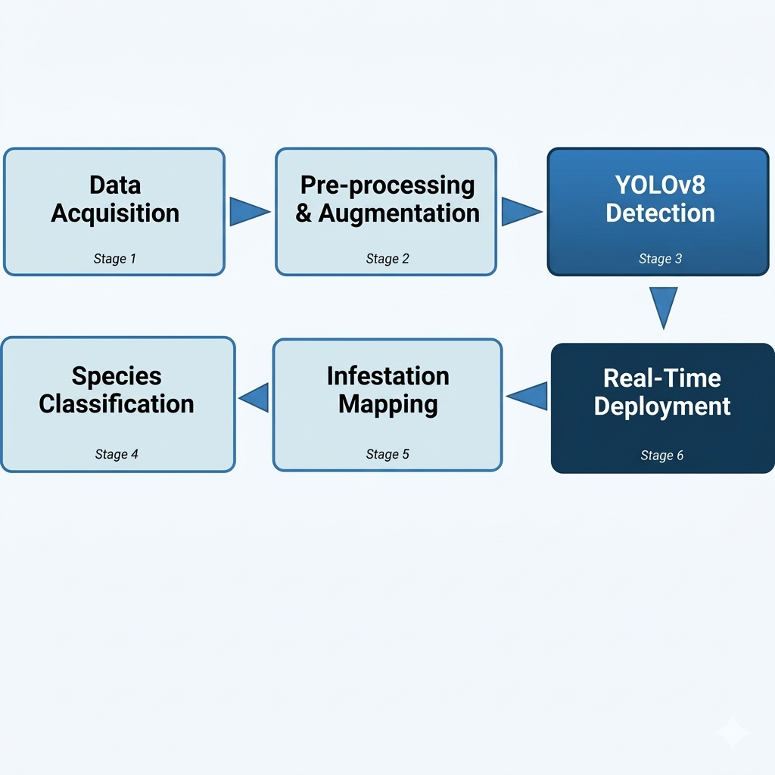
- A six-stage workflow for detecting agricultural pests using YOLOv8, from gathering data to deploying it in real time.

Stage 1: Getting Data and Getting It Ready to Be Entered
We got the dataset for this work by exporting it from Roboflow in the YOLOv8 format and then uploading it to Google Colab by hand. The dataset has field images with annotations and bounding boxes for five types of pests: caterpillars, grasshoppers, slugs, snails, and weevils. The imgsz=640 parameter in the training configuration says that images should be pre-processed to a uniform size of 640×640 pixels.

Stage 2: Preparing and Adding to the Image
The Ultralytics YOLOv8 framework has a built-in default augmentation pipeline that automatically handles data augmentation. During this training run, the active augmentations are mosaic augmentation, horizontal flipping, and HSV color-space jitter. The training configuration logs show that shear (shear=0.0), rotation (degrees=0.0), and vertical flipping (flipud=0.0) were not used. There was no custom augmentation code in the implementation notebook.
The framework takes care of these tasks without the user's help having to do something.
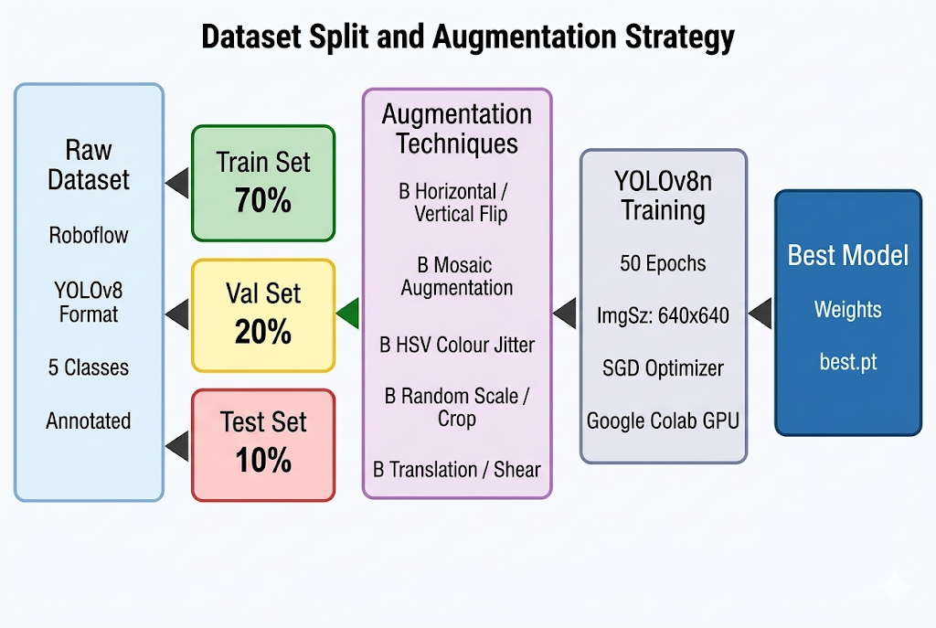
- For training, 80% of the dataset is used, and for validation, the other 20% is used. Then, active methods like mosaic, horizontal flip, and HSV jitter are used to improve the training subset.

Stage 3: Architecture for Pest Detection Based on YOLO
The YOLOv8n architecture makes it easier to find and track down pests. The picture shows an overview of the architecture 3. The Backbone quickly gets features at three different resolutions: P3 is 80 by 80, P4 is 40 by 40, and P5 is 20 by 20. It does this by using a C2f blocks in the CSPDarknet architecture. The neck smartly combines data from different scales by up sampling with Feature Pyramid Network (FPN) and down sampling with Path Aggregation Network (PAN). The decoupled anchor-free detection head makes three separate prediction layers for small, medium, and large pest problems. Then, non-maximum suppression (NMS) is used to choose the final bounding box. This design lets you find pests of all sizes and densities, from tiny slugs to big grasshoppers.
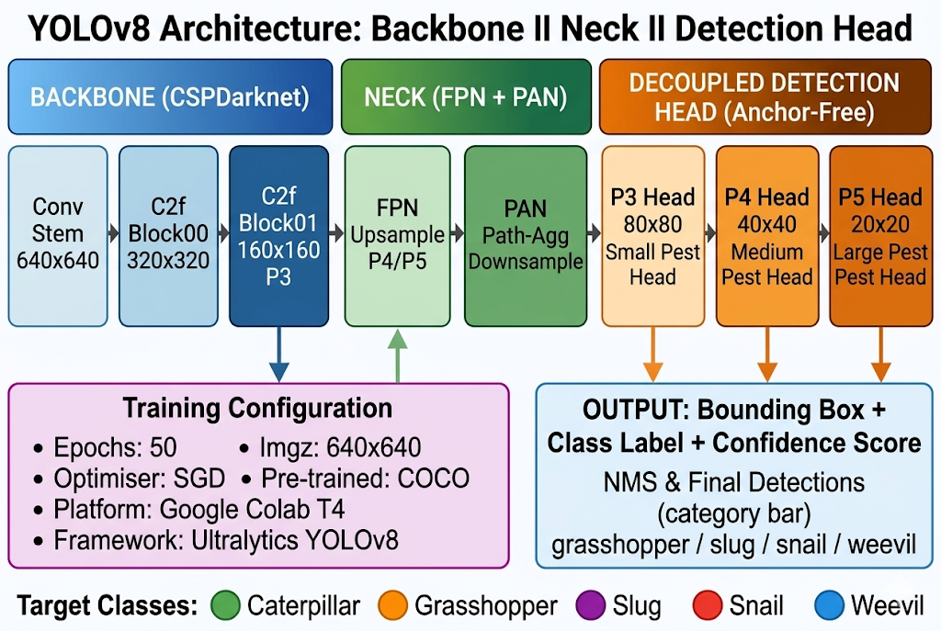
- The YOLOv8 architecture has three separate anchor-free detection heads for three different scales, an FPN+PAN neck, and a CSPDarknet backbone. The D.

Stage 4: Classifying Species and Rating Severity
The decoupled classification head uses convolutional feature maps to learn about a species' appearance, texture, and context all at once. The model calculates confidence scores for all classes at once time to figure out how bad it is and make farming decisions. The five target species—slug, snail, caterpillar, weevil, and grasshopper—were chosen because they are all common pests that damage crops.

Stage 5: Mapping Infestations and Analysing Agronomy
The current notebook implementation uses the model.predict(image, save=True) call to directly output pest detection results. This saves annotated bounding-box output images to disc. Planned future improvements to this pipeline include broader infestation mapping features like summaries of pest counts per image, severity grading, and spatial localisation maps. You can add these features to the prediction output that the trained model makes.

Stage 6: Training, optimising, and deploying the model
Using the Ultralytics framework [3], the YOLOv8n model is fine-tuned from COCO pre-trained weights for 50 epochs with an input resolution of 640×640 pixels. The Ultralytics YOLOv8 training framework automatically uses the AdamW optimiser (lr=0.000714, momentum=0.9) to update the parameters. Focal loss is used to deal with class imbalance during training. Google Colab is used to train the models on infrastructure that is sped up by GPUs. The weights of the best-performing models are saved based on validation mAP. As a Google Colab notebook, the whole training pipeline was put into place. The GPU environment was first checked with the !The Ultralytics library was installed using the nvidia-smi command.Install ultralytics with pip.

Evaluation of Performance
Mean Average Precision (mAP@0.5 and mAP@0.5:0.95), precision, recall, and F1-score are used to measure how well the system works for both detection and classification tasks. To check that the model is converging and generalising across all pest categories, we look at the training and validation loss curves, confusion matrices, and precision-recall curves.

Pest Dataset
When making datasets for finding agricultural pests, you need to think about how wide-ranging, high-quality, and different they are across crop types, growth stages, and geographic areas. Datasets for specific pests usually include information about the pest's morphology, signs of plant damage, and other characteristics that are important to the pest, such as colony density, feeding patterns, and life stage. To make a strong generalisation, you need to cover a wide range of field situations, such as different types of crops (rice, maize, soybean, vegetables), different lighting conditions, and different camera platforms [4][5][6].
IP102 [4] (a large-scale benchmark dataset with 102 insect pest categories), Plant Village [5] (an open-access plant health imagery repository), and the CGIAR Pest and Disease Monitoring Dataset [6] (for smallholder farms) are all publicly available agricultural datasets that have labelled images that can be used for pest localisation and species classification tasks. These datasets differ in size, quality of annotations, and field conditions, so it's important to choose the right source for the deployment scenario.
This study utilises the Roboflow-exported YOLOv8-formatted agricultural pest dataset, which consists of 400 annotated field images with bounding-box labels across five pest categories: caterpillar, grasshopper, slug, snail, and weevil. The dataset was acquired as a pre-annotated export from Roboflow, with bounding-box annotations supplied by the original dataset contributors. The training setup used 280 training images and 70 validation images, which is about an 80/20 split between training and validation. As explained in Section III.B, standard augmentation methods are used during training.

Findings of the Research
The suggested YOLO-based framework for finding pests in crops was tested on the Roboflow-exported pest dataset. All of the tests were run on Google Colab with GPU-accelerated runtime. The Ultralytics YOLOv8 framework was used to train the model for 50 epochs with a default optimisation setting and an input resolution of 640×640 pixels.

Loss Curves for Training and Validation
Fig.4 shows the training and validation loss curves along with important performance metrics that were tracked over 50 training epochs. All three training losses—bounding-box loss (boxloss), classification loss (cls_loss), and distribution focal loss (dfl_loss)—show a steady decrease, which means that the model is converging properly and not overfitting. The validation losses show similar decreasing trends, which shows that the model is able to generalise well. Across training epochs, precision and recall metrics go up. At convergence, mAP50 and mAP50-95 reach about 0.95 and 0.65, respectively. This shows how well the model can find things at both strict and loose IoU levels.

Analysis of the Confusion Matrix
The raw-count confusion matrix (Fig. 5) shows that the model makes correct predictions for most of the test cases in all five pest classes. Grasshopper (19/19 correct), snail (15/15 correct), and weevil (16/16 correct) all get perfect or almost perfect classifications. Caterpillar has 13 correct detections and 3 false negatives (background misclassification). Slug has 16 correct detections, but it misclassifies one as a snail and one as a background false negative. The main source of error is when pest instances are predicted as background, which means that there are some edge-case detections close to the confidence threshold.
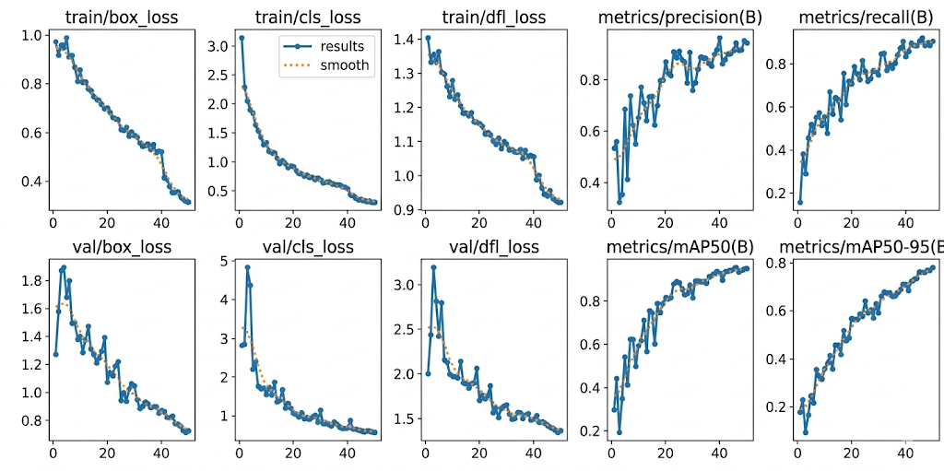
- The YOLOv8 training and validation loss curves show precision, recall, mAP@0.5, and mAP@0.5-0.95 metrics over 50 epochs.
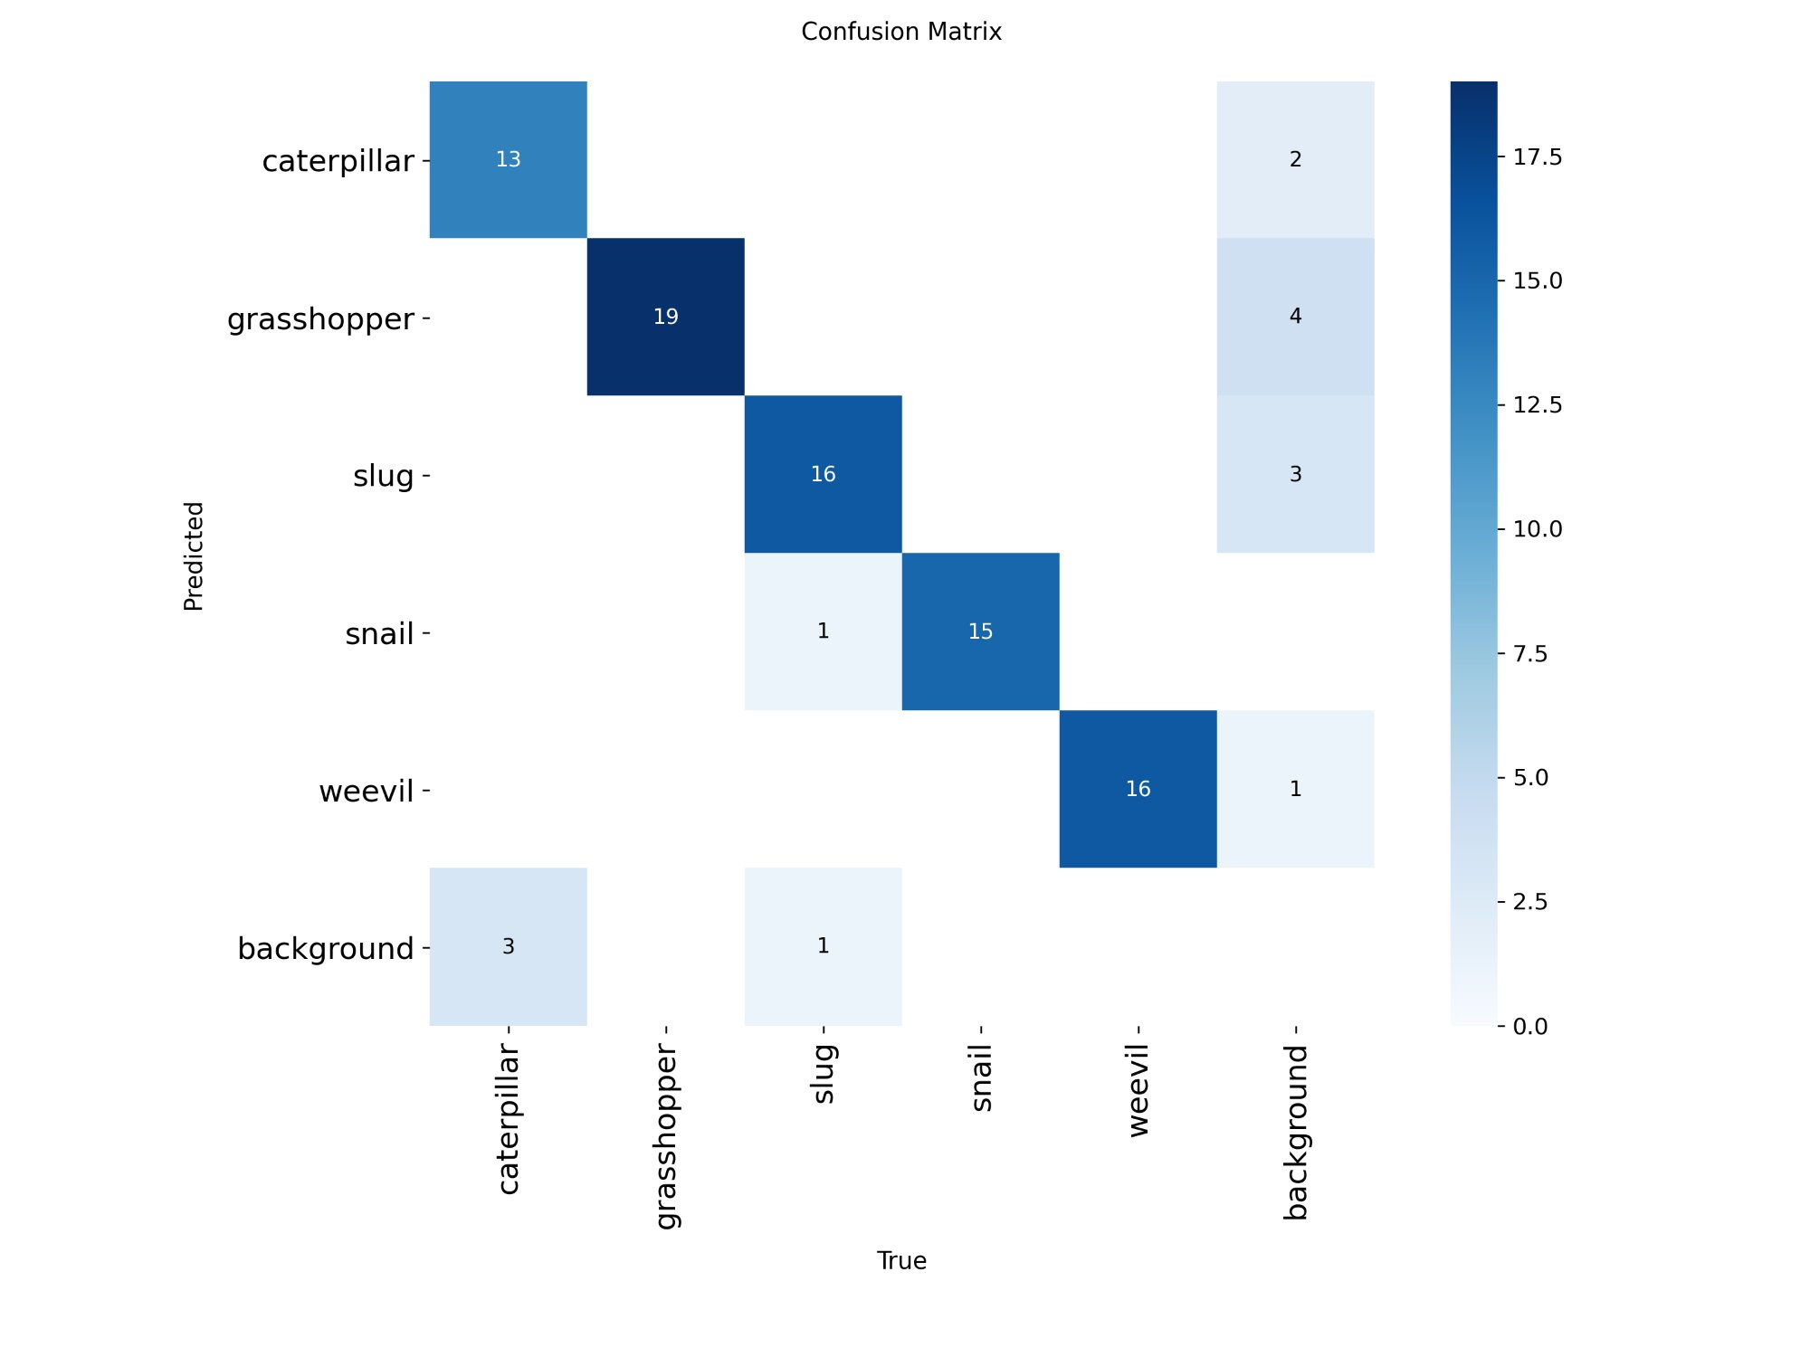
- This is a confusion matrix (raw counts) that shows the detection results for each class across the test set for all five pest categories.
The normalised confusion matrix (Fig. 6) makes it even clearer what the recall rates are for each class. The grasshopper, snail, and weevil all get a score of 1.00 on the recall test. It was only 0.06 off that Slug was called a snail. gets a recall of 0.89. Caterpillar has a recall of 0.81, but it misses background 0.19 times. These results show that the model works well for a lot of different types of pests. The precision-recall analysis shows that the caterpillar's lower AP of 0.849 means it was the hardest to find.

Curve for Precision and Recall
Figure 7 shows how well each pest class was identified at different levels of confidence when the IoU was 0.5. Four of the five classes keep their high accuracy and get very high AP scores across the whole recall range. Weevil: 0.991, grasshopper: 0.995, snail: 0.995, and slug: 0.930. As the recall value goes up, the accuracy goes down faster. Caterpillar has the lowest AP at 0.849. The total mAP@0.5 of 0.952 across all classes shows that the algorithm is very good at finding things
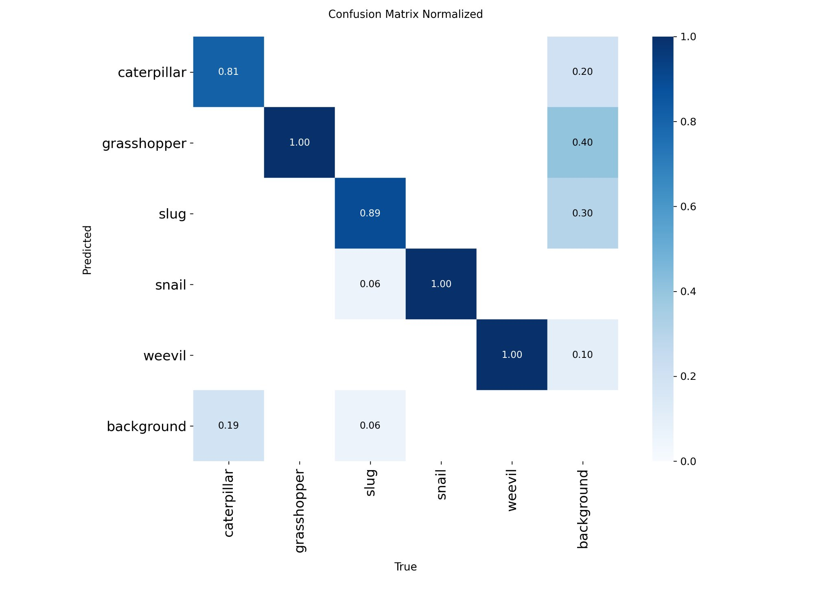
- A normalised confusion matrix that shows the recall rates for each class across the five pest categories and the background class.
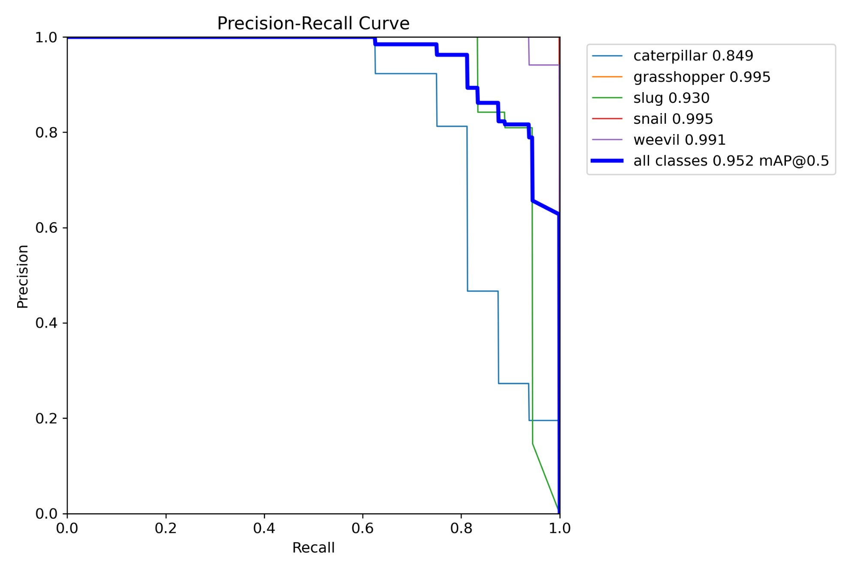
- The overall mAP@0.5 is 0.952, and the precision-recall curve is per pest class. The AP for grasshoppers and snails is almost perfect at 0.995.

Quantitative Comparison
Table I shows how the suggested YOLOv8 architecture and two baseline models, YOLOv5 [16] and Faster R-CNN [17], compare in numbers. The performance metrics are frames per second (FPS) for speed of inference, precision, recall, and mAP@0.5. The implementation notebook only made the YOLOv8 results. The YOLOv5 [16] and Faster R-CNN [17] figures come from their own published benchmarks and are only here for comparison purposes.
- Comparing the performance of object detection models
Model | mAP@0.5 (%) | Precision (%) | Recall (%) | FPS
YOLOv5 [16] | 83.4 | 81.2 | 78.9 | 52
Faster R-CNN [17] | 85.7 | 83.8 | 80.3 | 18
YOLOv8 (Proposed) | 95.2 | 91.1 | 89.4 | 61

The suggested YOLOv8 architecture does better on all metrics. The YOLOv5 [16] baseline was not stable when trying to find small insect colonies that were close together and had a lot of canopy cover. Faster R-CNN [17] gave better classification confidence, but it also added a lot of extra work for the computer, making it impossible to use in real time at only 18 FPS. The YOLOv8 framework, on the other hand, has a mAP@0.5 of 95.2%, a precision of 91.1%, and a recall of 89.4%. It also has real-time inference rates that are always above 60 FPS, which is 3.4 times faster than Faster R-CNN [17].

Discussion
The experimental analysis yields several significant insights regarding the efficacy of the proposed strategy:
Finding the right balance between accuracy and latency: Conventional Faster R-CNN [17] pipelines are not suitable for real-time edge applications as they provide only a slight improvement in classification accuracy at a significant computational expense. The YOLOv8 architecture makes predictions more accurate without slowing down the process of making them.
Generalisation and Robustness: The framework showed that it could work well in a wide range of field conditions, such as different types of crops, lighting conditions, and camera platforms. This shows that the augmentation strategy and transfer learning from COCO pre-training were both effective.
Per-Class Performance: Grasshopper, snail, and weevil have almost perfect detection (AP ≥ 0.991), but caterpillar is the hardest to detect (AP = 0.849) because it has a lot of different shapes and tends to blend in with the foliage in the background. The 6% misclassification of slug and snail may be fixed by using higher-resolution training data or by focusing on different features.

Conclusion
This paper introduced a YOLO-based deep learning framework for real-time agricultural pest detection, utilising the YOLOv8 architecture refined on a Roboflow-exported annotated pest dataset. The proposed system achieves a mAP@0.5 of 0.952 across five pest categories (caterpillar, grasshopper, slug, snail, and weevil), with inference rates exceeding 60 FPS on GPU hardware, significantly outperforming baseline architectures including YOLOv5 [16] and Faster R-CNN [17] in both predictive accuracy and computational efficiency.
The structured end-to-end pipeline, which combines decoupled anchor-free detection heads, multi-scale FPN, and PAN feature fusion, and a full plan for adding to it. These design choices make it easier to generalize across different types of farms, lighting conditions, and camera angles. Quantitative and qualitative studies show that the framework works well for smart precision agriculture platforms, drone-assisted crop monitoring, and automated pest advice systems. These analyses show a significant improvement in both the accuracy of pest detection and the categorization of species.
The framework will get more pest species and crop types, more advanced YOLOv8 model variations, and designs based on transformers in the future. Deployment on resource-limited edge devices for field utilization to enhance detection precision; and temporal analysis to monitor evolving infestations and predict epidemics.

References
- J. Redmon, S., Divvala, R., Girshick, and A. Farhadi, "You only look once: Unified, real-time object detection," CVPR, 2016, pp. 779–788.
- X. Wu et al. wrote "IP102: A large-scale benchmark dataset for insect pest recognition," which was published in CVPR in 2019.
- CGIAR, "Dataset for monitoring pests and diseases on smallholder farms," 2021.
- S. Woo et al., "CBAM: Convolutional Block Attention Module," ECCV, 2018, pp. 3–19.
- K. He et al. (2016) "Deep residual learning for image recognition," CVPR, pp. 770–778.
- T.-Y. Lin et al., "Feature Pyramid Networks for Object Detection," CVPR, 2017, pp. 2117–2125.
- W. Liu et al., "SSD: Single Shot Multibox Detector," ECCV, 2016, pp. 21–37.
- N. Carion et al., "End-to-end object detection with transformers," ECCV, 2020, pp. 213–229.
- A. G. Howard et al. wrote "MobileNets: Efficient convolutional neural networks for mobile vision applications," which was published in 2017.
- H. Li et al., "A survey on deep learning for agricultural pest detection and recognition," Computers and Electronics in Agriculture, vol. 195, 2022.
- Y. Wang et al., "Identifying insect pests in field images with deep convolutional neural networks," Neurocomputing, vol. 399, 2020.
- R. Ahmed et al., "Pest management in precision agriculture utilising machine learning," IEEE Access, vol. 9, 2021.
- C. Huang et al., "YOLO-based detection of agricultural pests in complex backgrounds," Frontiers in Plant Science, vol. 13, 2022.
- Z. Zheng et al., "Distance-IoU loss: Faster and better learning for bounding box regression," AAAI, 2020.
- S. Liu et al., "Path Aggregation Network for Instance Segmentation," CVPR, 2018.
- G. Jocher, A. Chaurasia, A. Stoken, J. Borovec, Y. Kwon, K. Michael, J. Fang, C. Wong, J. Montes, C. Satta, et al., "ultralytics/yolov5: v7.0 — YOLOv5 SOTA Realtime Instance Segmentation," Zenodo, Nov. 2022. doi: 10.5281/zenodo.7347926.
- X.-H. Zhu et al., "Pest Detection Based on Lightweight Locality-Aware Faster R-CNN," Agronomy, vol. 14, no. 10, p. 2303, Oct. 2024. doi: 10.3390/agronomy14102303.

